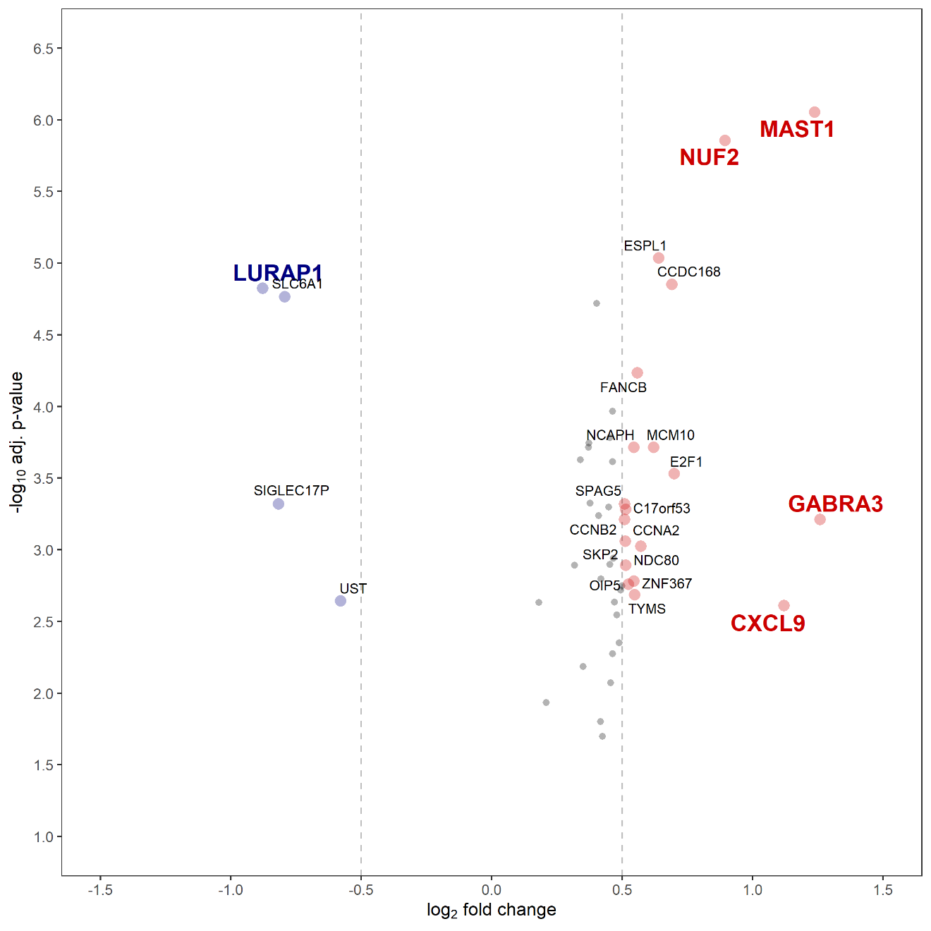
Supplementary Figure S1. Volcano plot of the 49 genes in the LogitDA model predictor of IMvigor210-PCD(mUC). The plot displays five genes differentially expressed between responders (CR/PR) versus non-responders (SD/PD), identified after Benjamini-Hochberg correction (adjusted P < 0.005) and an absolute log₂ fold change (FC) ≥ 0.85.

